# **Hotel Booking and Car Rental Management**

***Overview:***

The objective is to expand the Flight reservation System with booking hotels and car rentals for the users.

***Object Model:***

This object model is an extension of the Flight reservation System.

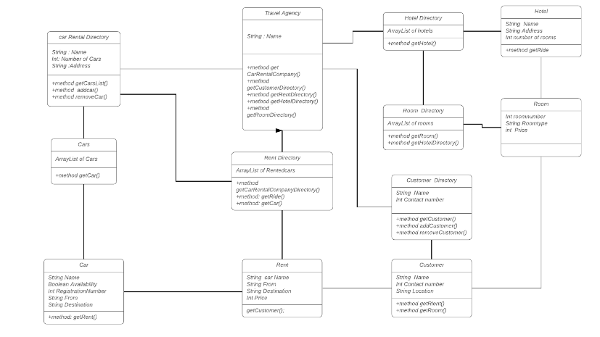

***Travel Agency:***

Travel Agency is responsible for renting Cars and booking hotel rooms for Customers. The getRentalDirectory() would provide all the information about the available Cars for the Customer. The getCustomerDirectory() provides an arraylist of customers with all the data related to customer. The getHotelDirectory() would provide the details of all the available hotels in a particular location.

***Car Rental Directory:***

Car rental directory has a list of Car Rentals in a particular location. The getCarList() would provide list of all available cars. The addCar method adds a car to the arraylist. The removeCar() method would remove the car from the arraylist.

***Car:***

Car has all the information related to a particular car. Such as the name, Availability, from and destination. The getRide() would provide the Car with the Ride details.

***Rent:***

The getCustomer() would provide all the details about the Customer to the Car entity.

***Rental Directory:***

Rental directory is an Arraylist of all available Cars for rent in a particular location. The getRent() method will provide all the information related to the rental car. The getCars() would provide all the List of cars.

***Customer Directory:***

The Customer Directory is responsible for maintaining all the information related to the Customer. It is an arraylist of customers. The getCustmer() provides all the details related to the customer. The add Customer method adds a customer to the Arraylist. The removeCustomer() removes a customer from the arraylist.

***Customer:***

The Customer is has all the information about the customer such as the Customer name, Customer contact and location. The getRent() provides the information related to renting a Car. The getRoom() method provides all the details about the room in a particular hotel.

***Hotel Directory:***

Hotel Directory has an arraylist of all the hotels in a location. The getHotel() provides the information related to hotels like name, address and number of rooms.

***Hotel:***

Hotel has attributes of the hotel like name of the hotel , address of the hotel and the number of rooms in the hotel. getRide() method will help to connect with a ride.

***Room:***

Room has attributes of a room like roomnumber, Roomtype and price.

***Room Directory:***

Room Directory has an arraylist of all the rooms . The getRoom() provides the information about the room. getHotelDirectory() will provide the details of the hotel list to the room directory.

***Proposed Solution:***

Hotel Management and Car Rental Application will help to manage all bookings of the room from different hotels throughout the stay and it will also help the users with other services like renting a car and booking another travel with the same portal and with the same credentials throughout the trip from one place to another.

***Future Scope:***

The Future scope can be improved by providing the booking of hotels, renting cars and booking different tourism plans for the customer. The future scope also includes providing support for multiple stops between the source and the destination.

***Conclusion:***

Hotel Management and Car Rental system will help the User to book a room in a hotel by checking the availability and price. It also helps the user to rent a car associated with the hotel and as it is linked with the Airline management system the same details of the customer is used in all the further bookings. Hence help the customers to book everything in a single place.